**GAME REPORT**

**Game concept / idea**

* A 2D platform RPG with catching mechanics like Pokemon.

**Description**

* The player wants to defeat all the evil enemies, who are destroying the world. He will have to slay or capture the boss of the dark side to save the world. He can capture monsters along the way to help him against the boss battle.

**Problems encountered / how it was solved**

1. Player Collision was not working in the near the end of week 2. It has affected the whole game and we could not progress.

**How it was solved:** Dropped the current framework and worked on a new one. We progressed on very quickly but we had to drop some of our initial features

1. Menu GUI would not work properly when integrated during week 2. So, we had to change it accordingly. The buttons would not show up, or it’s translation would be incorrect.

**How it was solved:** Using another orthographic view, and translate them based on Screen-size.

1. Our tile-map was being rendered, without depending on tile-size. Which resulting a lot of problem encountered.

**How it was solved:** We redo our CSV file reader, including tile-size when it reads the csv.

**Lessons learnt**

1. DLL - We learnt how to create a dynamic link library during our process through studio project. It have helped us to work much faster, when we have to switch over to a new framework.
2. When creating a tile-map game. Many things have to be planned before hand before starting on creating the map. We need things like Map offsets, Character offsets, Size of every Tile, and many more. These elements have to be included in the game, to make it easier to work.

**Gantt chart**

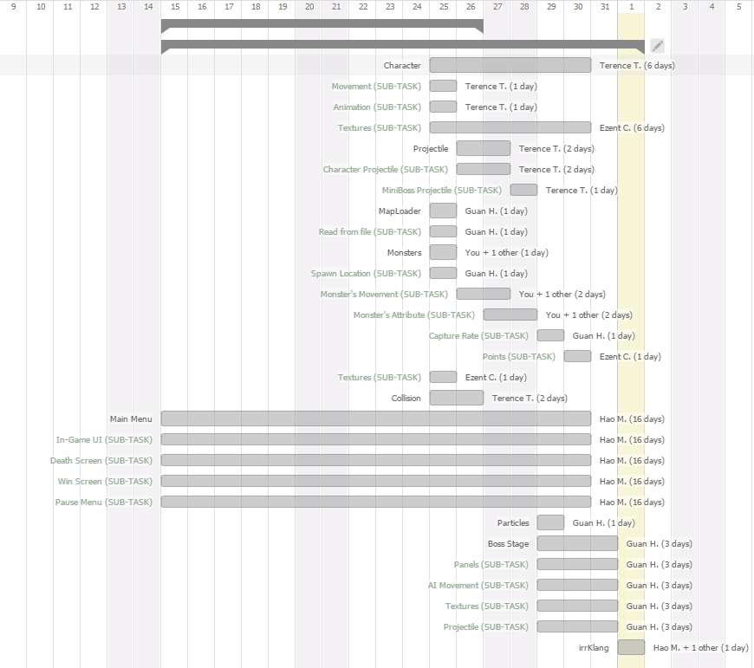

**GAME DESIGN DOCUMENT**

**Introduction:** 2D RPG Platformer.

**Background, Story:**

* The player wants to defeat all the evil enemies, who are destroying the world. He will have to slay or capture the boss of the dark side to save the world. He can capture monsters along the way to help him against the boss battle.

**Control & Interface:**

* **Normal Stage**

W, A, D - Basic Movements

Spacebar - Jumping

J - Shoot weapon

K - Charge weapon

L - Capture Monsters

P - Pause Game

* **Boss Stage**
* W, A, S, D - Basic Movements
* K - Shoot weapon
* P - Pause Game

BOSS1.png

**Characters & Units:**



Normal Mob Normal Mob Mini Boss Mob Final Boss

**Concept Art & Game Assets:**

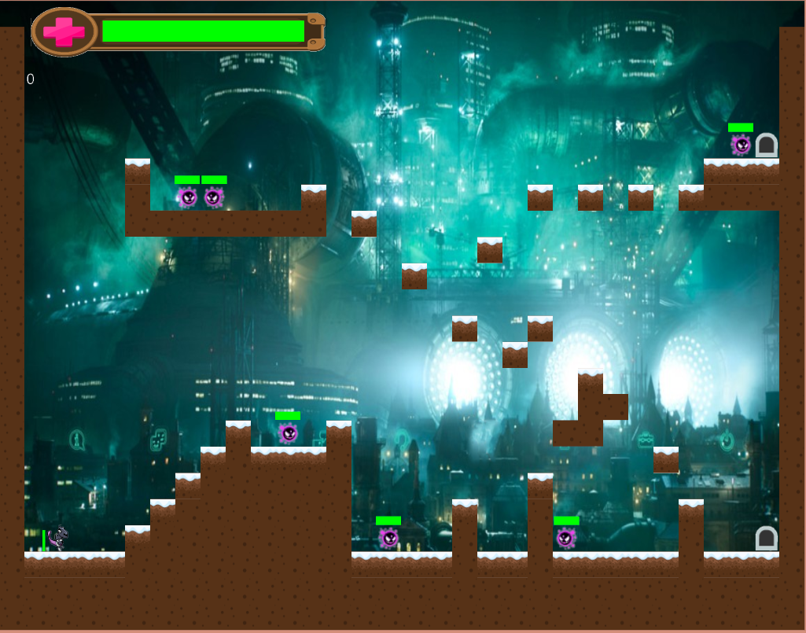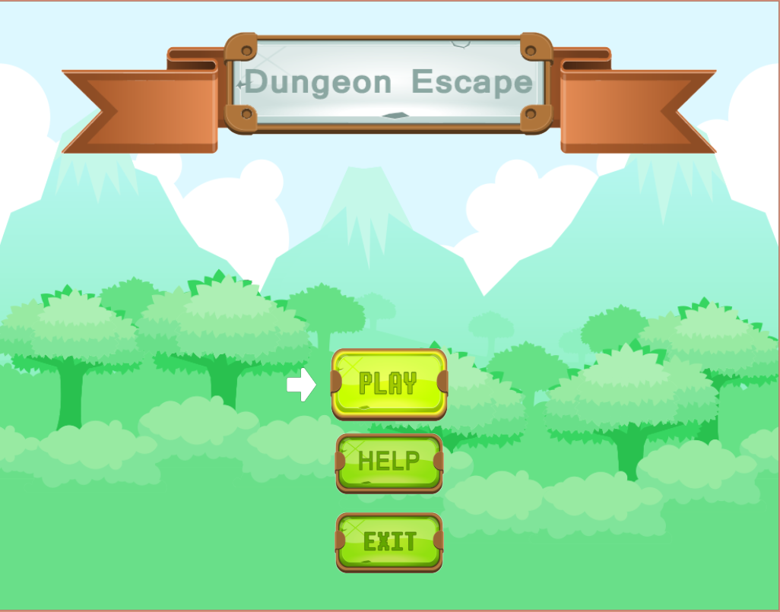

**Menu GUI In Game UI**

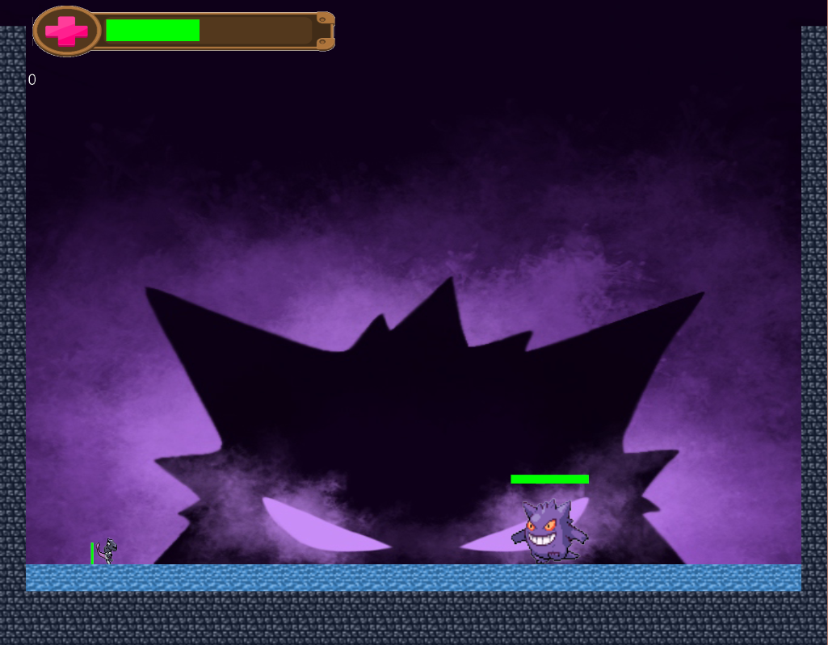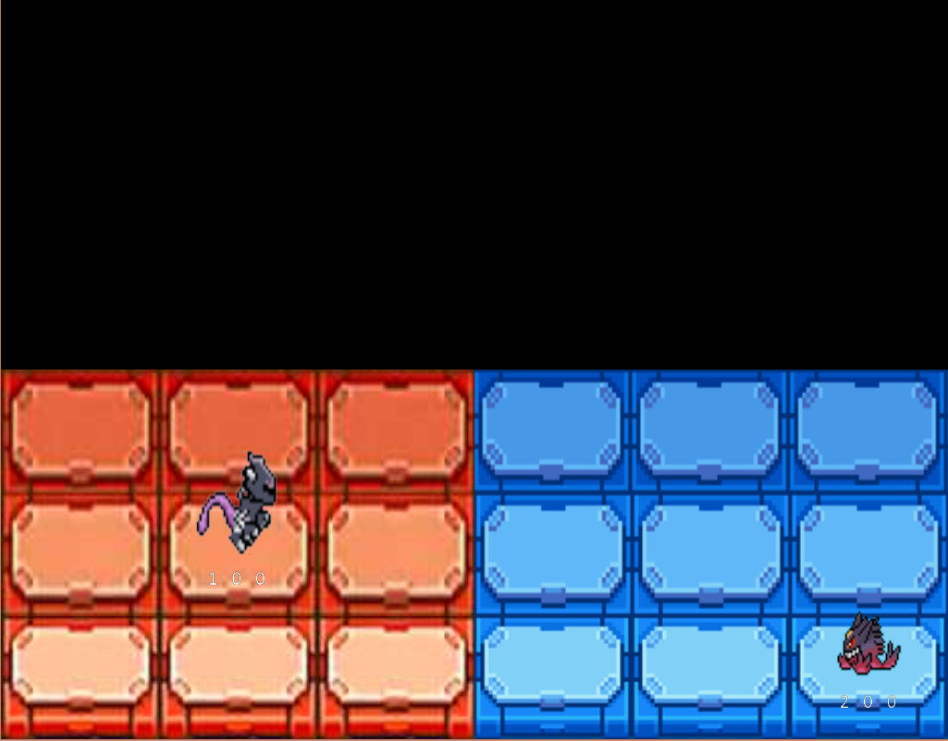

**MiniBoss UI Final Boss UI**